**Power BI**

**Credit Card Financial Dashboard**

**5 Steps:**

1. **Project Overview**

Here, we will see what problem statement we are going to solve & what we will create in this project.

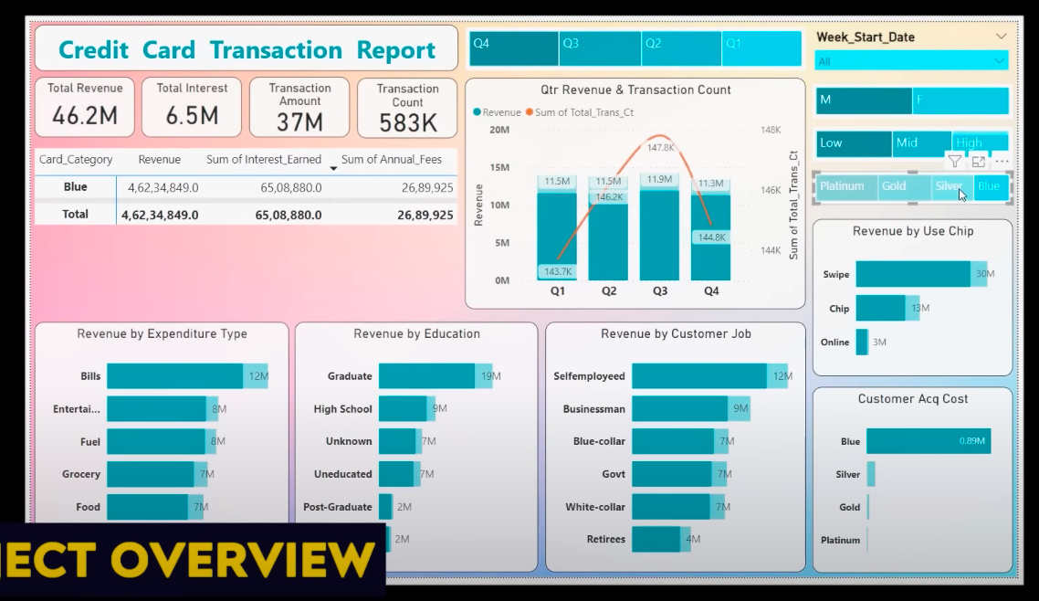

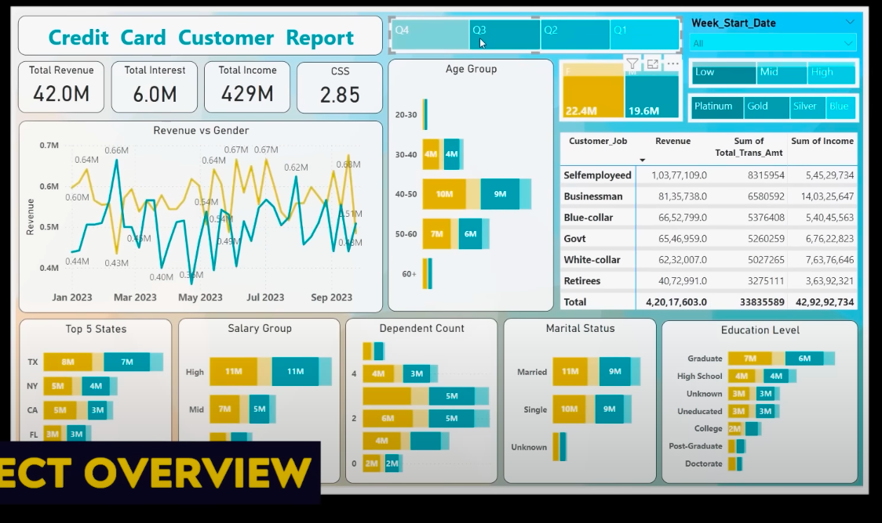

1. **Data Extraction**

We will connect the Power BI to our SQL Database.

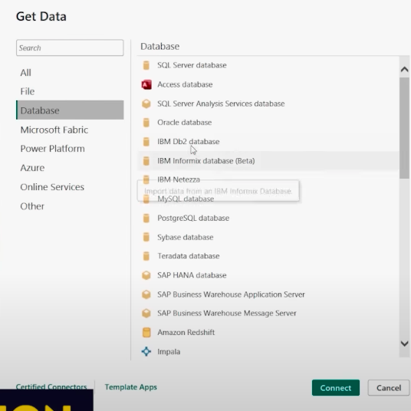

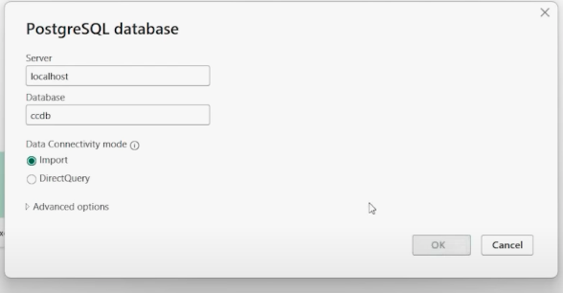

Then, we will import the data into Power BI.

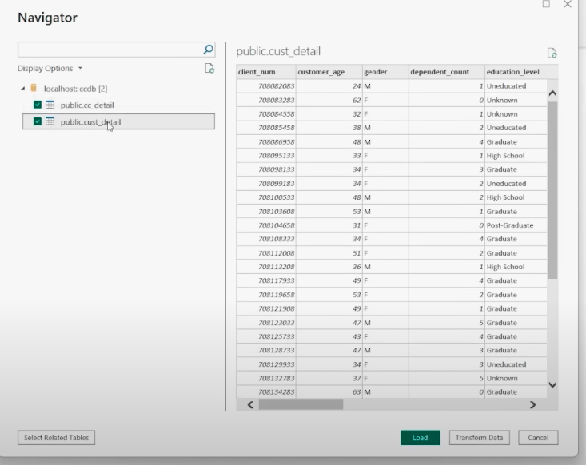

Then, we will create the Dashboard.

1. **Data Processing & DAX Queries**

Here, we will do some calculations, data process, and perform some formulas/functions to create new columns/charts.

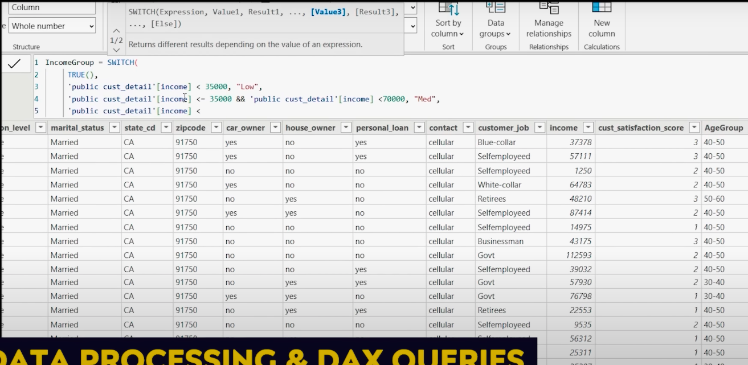

1. **Dashboard & Insights**

Here, we will create 2 dashboards & share their insights.

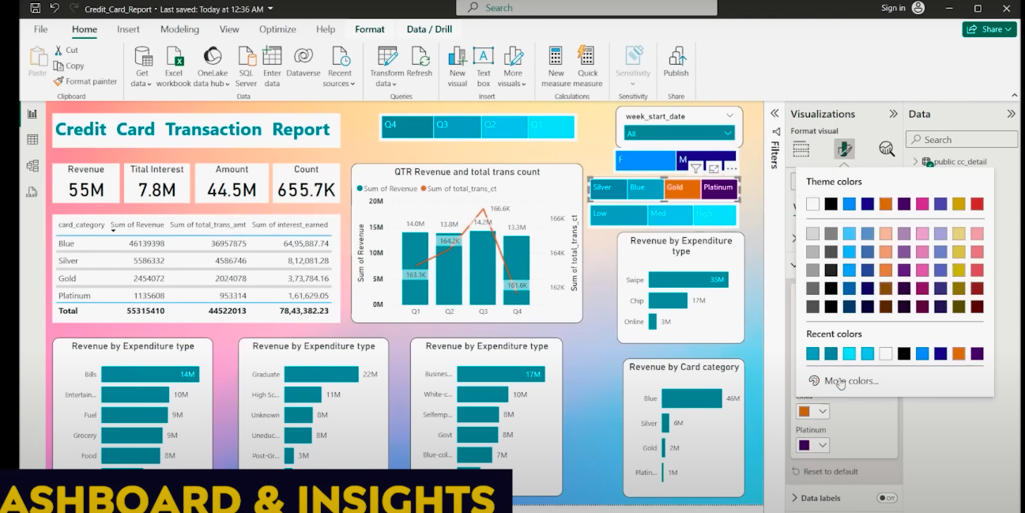

1. **Export & Share**

Here, we will export this Power BI dashboard, then upload on Github & will share the Github link on LinkedIn.

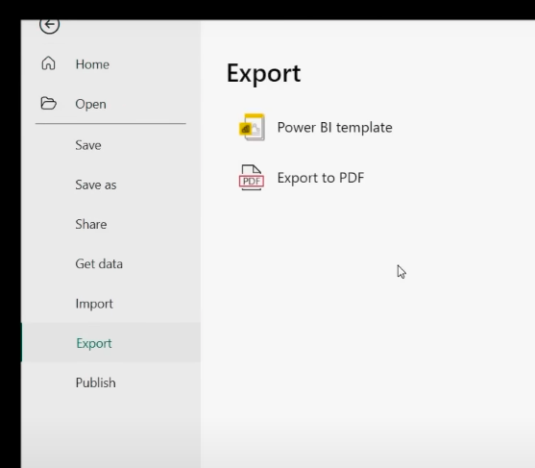

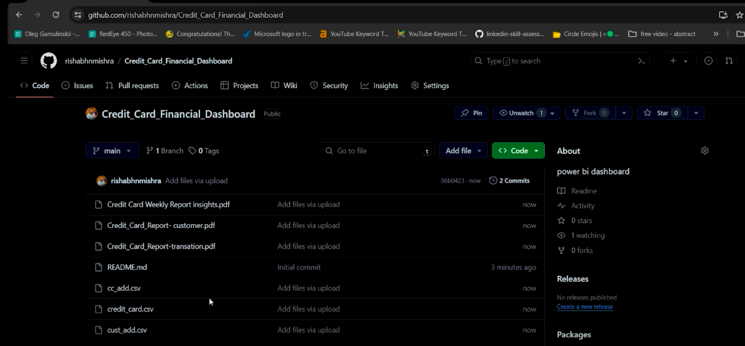

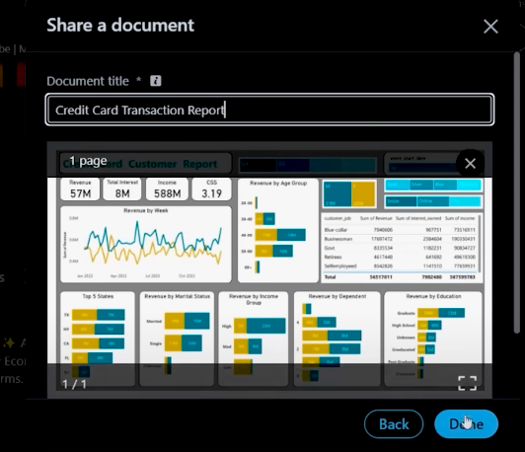

**XXXXXXXXXXXXXXXXXXXXXXXXX**





Dashboard 1:

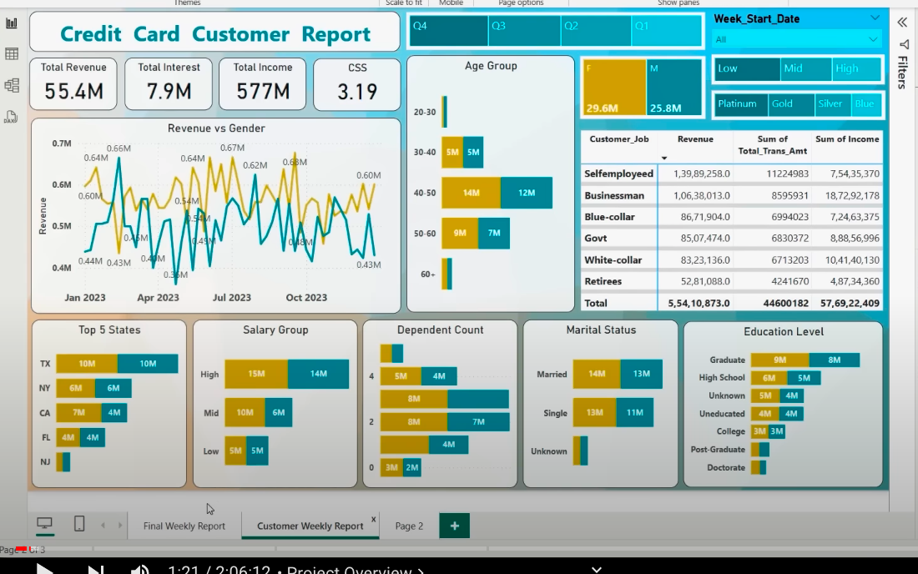

Dashboard 2:

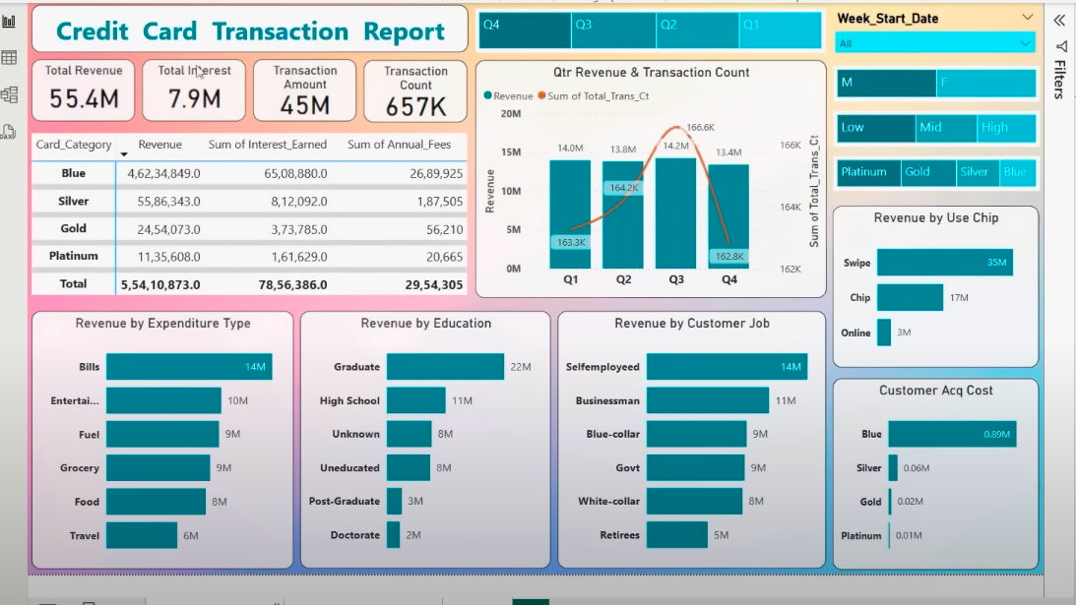

The data we would be working on:

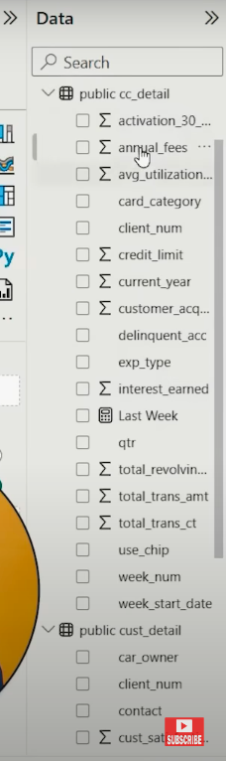

**Dashboard 2: CC Transaction**

**Filters:**

Filter 1: **Weeks** for a whole year (Week 1 to Week 15)

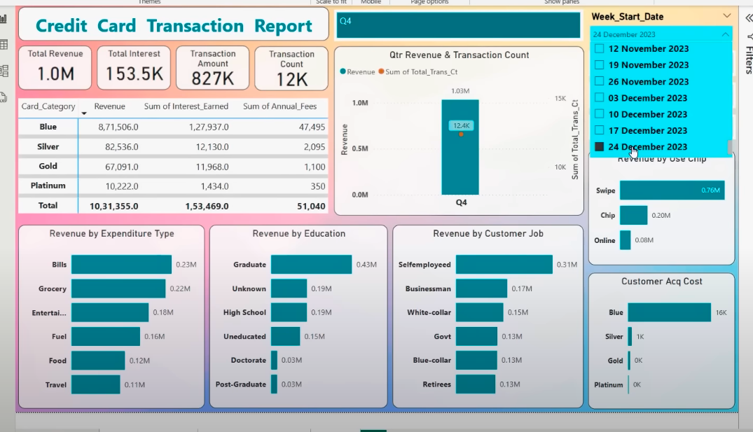

Filter 2: **Gender** (M/F)

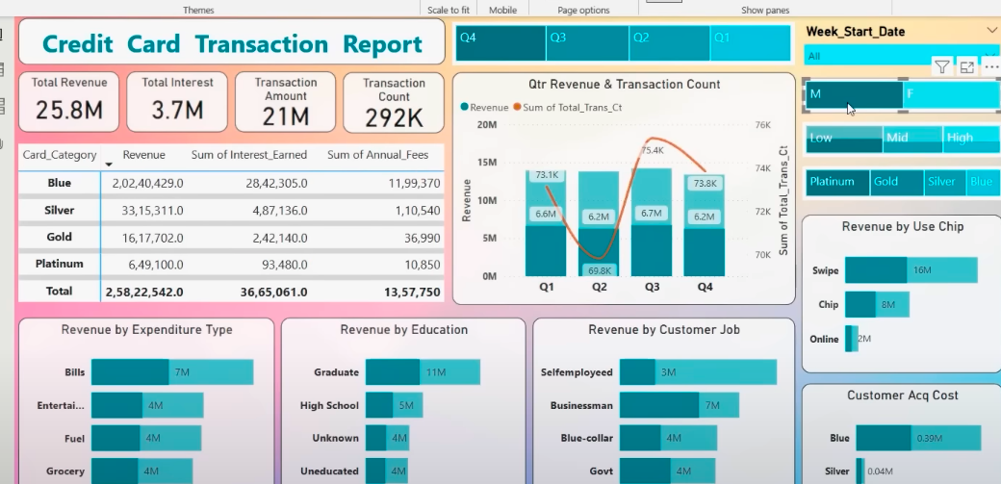

Filter 3: **Income Range** (Low/ Medium/ High)

Filter 4: **Card Type** (blue/ silver/ gold/ platinum)

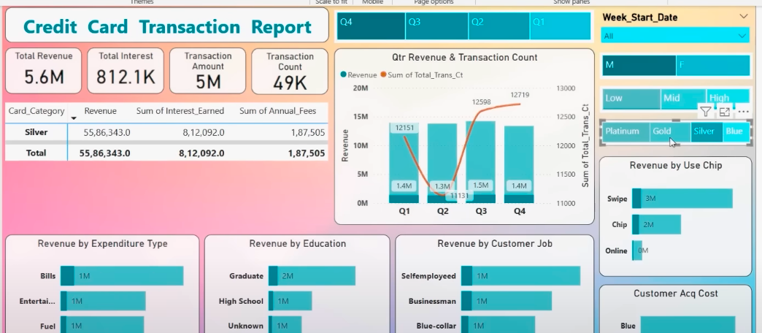

These filters are based on **TREE MAP** structure

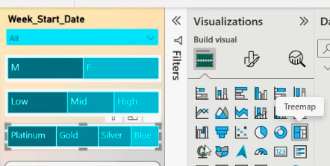

Filter for 4 different quarters

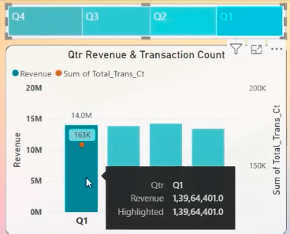

Putting the main **KPI** values into **Cards**

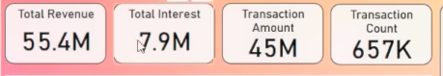

A Table based on **Card Category** – **Revenue**, **Sum of Interest Earned**, **Sum of Annual_Fees**

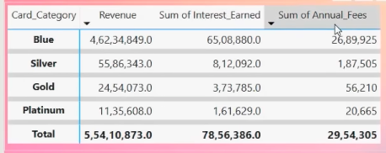

Now, some **Column Charts** that compares **Revenue** with different factors (Expenditure Type, Education, customer job, Use chip, & Acq cost)

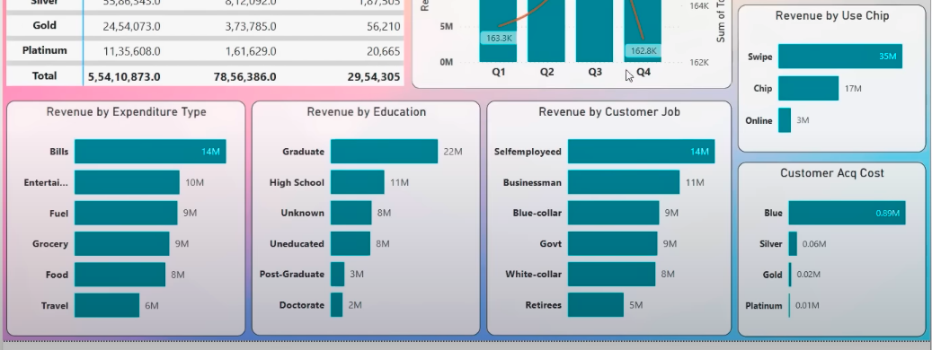

XXXXXXXXXXXX

**Dashboard 1: CC Customer**

**Filters:**

Filter 1: **Weeks** for a whole year (Week 1 to Week 15)

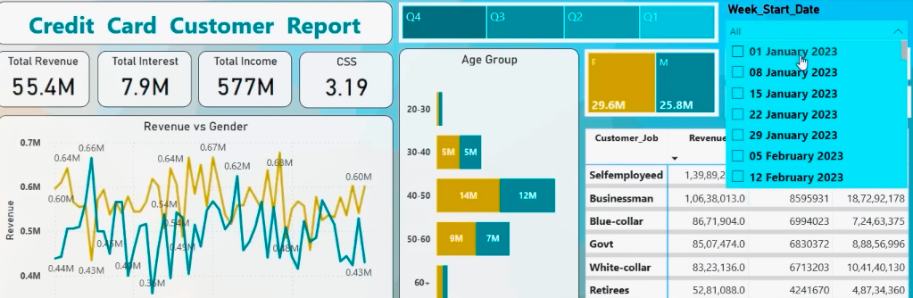

Filter 2: **Gender** (M/F)

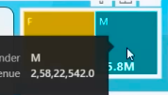

Filter 3: **Income Range** (Low/ Medium/ High)

Filter 4: **Card Type** (blue/ silver/ gold/ platinum)



These filters are based on **TREE MAP** structure

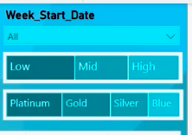

Revenue VS Gender chart on a weekly level

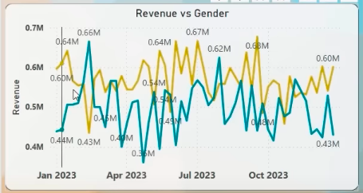

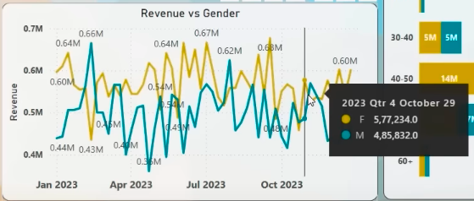

Putting the main **KPI** values into **Cards**

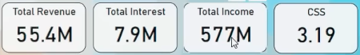

Here, CSS – Customer satisfaction score (out of 5)

**Age group** of customers

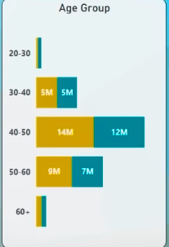

A Table based on **Customer job** – **Revenue**, **Sum of Total_Trans_Amount**, **Sum of Income**

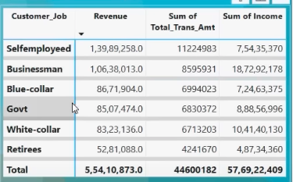

Now, some **Column Charts** that compares **Customers count** with different factors (state wise, salary group, dependent count, marital status, & education level)

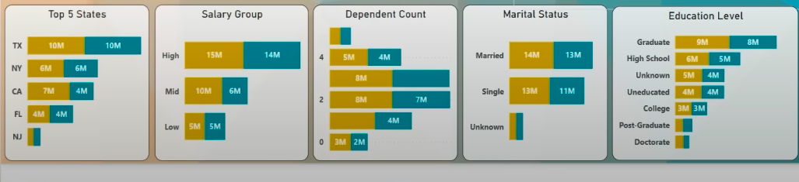

**Note: The whole dashboard template is finalised once only; Later on, we just need to refresh it on the next week.**

**As soon as we get the next week data, we just have to add the newly added week data and refresh this existing template. Hence, all the KPIs/charts/tables will be updated automatically.**

**XXXXXXXXXXXXXXXXXXXXXXXXX**





Credit Card Table

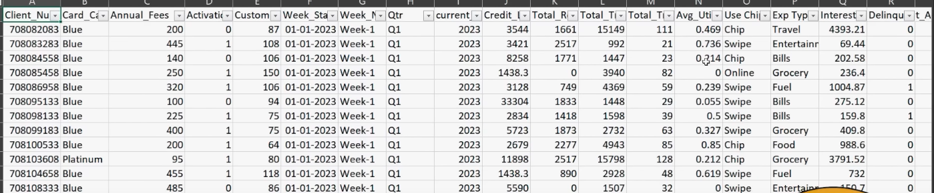

Customer Table

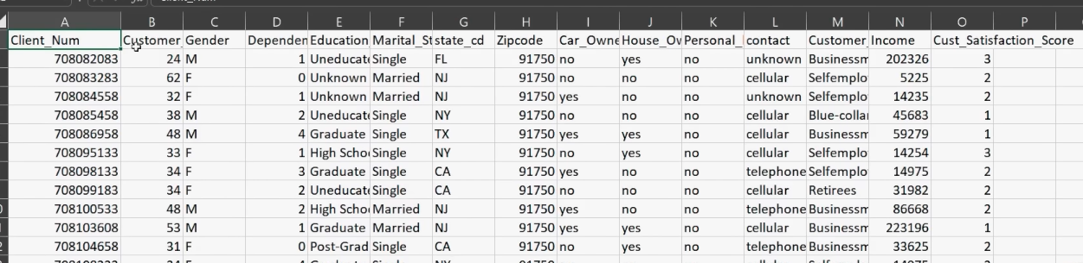

**Importing the CSV files into PostgreSQL**

Way 1: create the **database** & **tables** without SQL commands

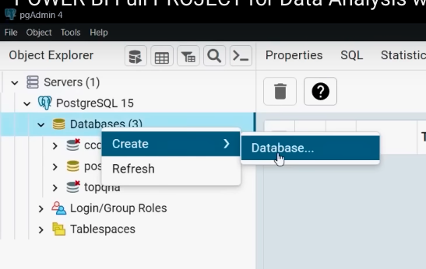

Way 2: Query Tool



Create Database, Tables & copy the data into tables from .csv files

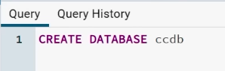

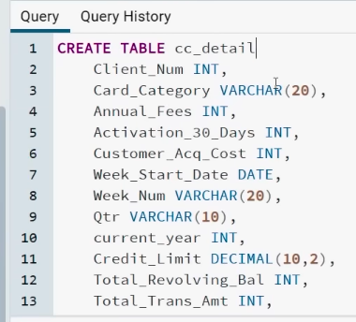

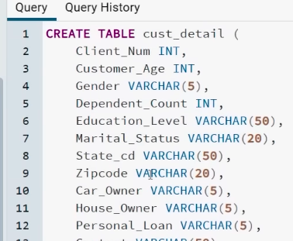

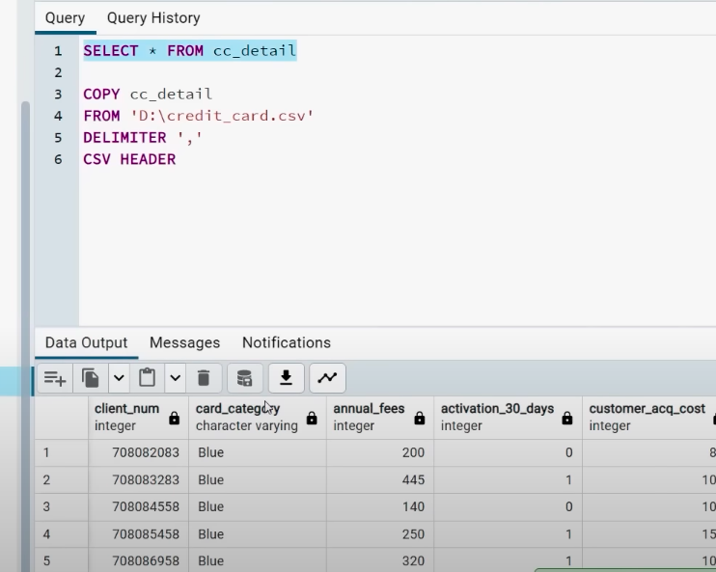

XXXXXXXXXXXX

Now, go to Power BI and connect to the PostgreSQL database **ccdb**, then import this data table into **Power BI**

**Connect to PostgreSQL 14**

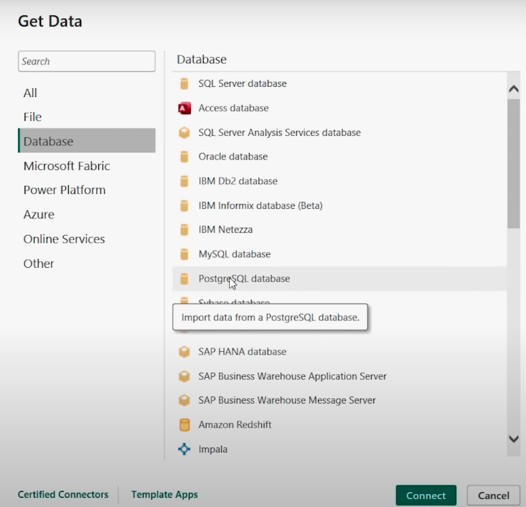

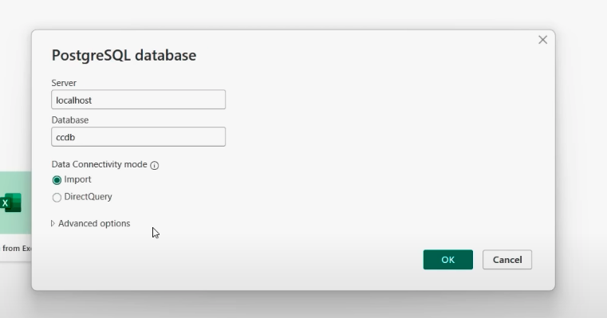

Here, we will choose **Import**, we choose **DirectQuery** when our data is on the cloud.

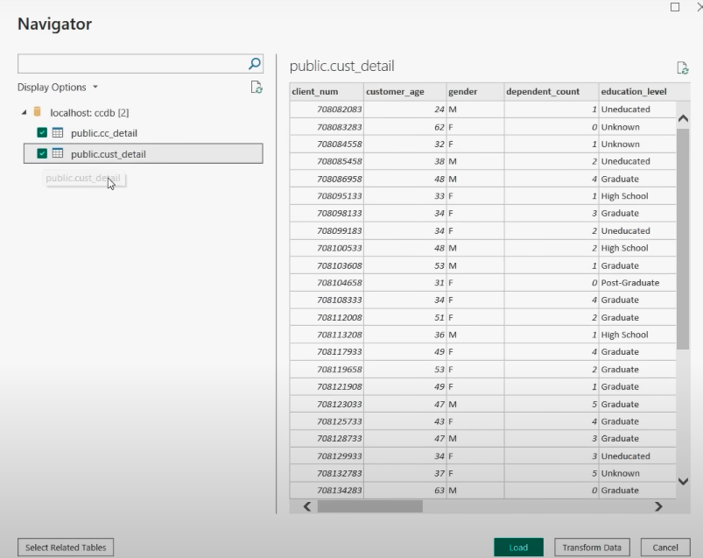

Select both tables and press **Load**

**XXXXXXXXXXXXXXXXXXXXXXXXX**



Press [Ctrl + S] and save the Power BI file.

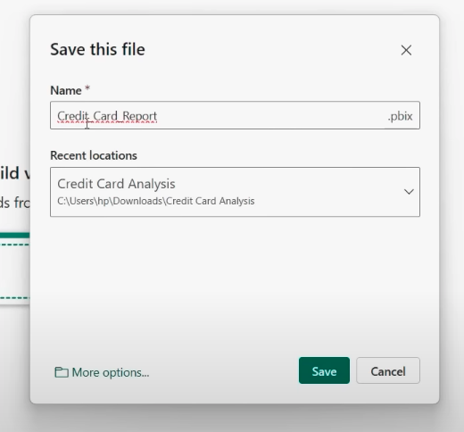

**Note: Never do Data Cleaning inside Power BI because it will make the dashboard slow. Always do the Data Cleaning with SQL or Python.**

Data Cleaning in Power BI:

* Any numeric/alphabetic value present in the Age column
* Format of date
* Missing values
* Duplicate values

DAX Queries:

Depends on which functions/ formulas/ metrics you want to make

1. Creating **Age Groups:**

Cust_detail --> New Column --> AgeGroup

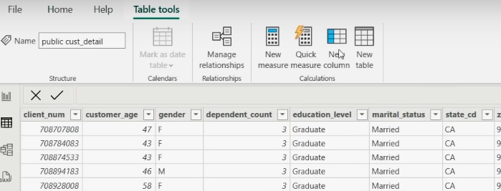

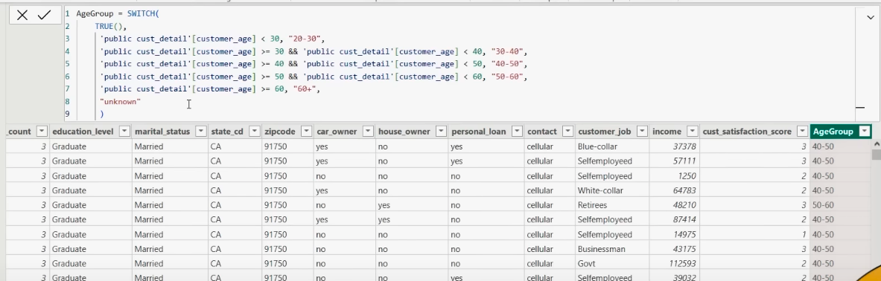

1. Creating **Income Groups:**

Cust_detail --> New Column --> IncomeGroup

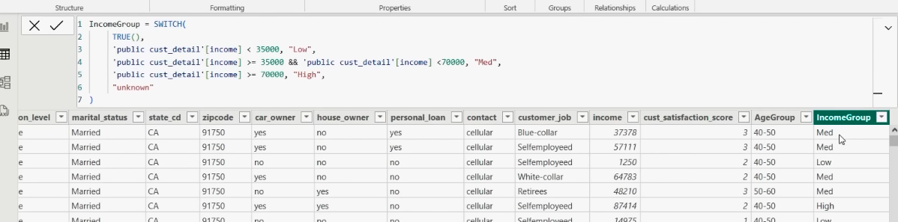

1. Making a new column to get the **Revenue** value

Now, it is upto you how you wanna calculate the Revenue

Go to **public.cc_detail** --> **New column**

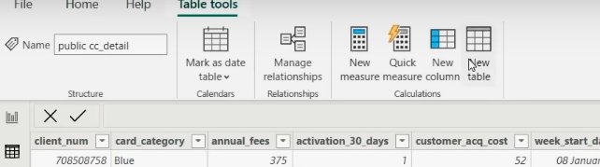

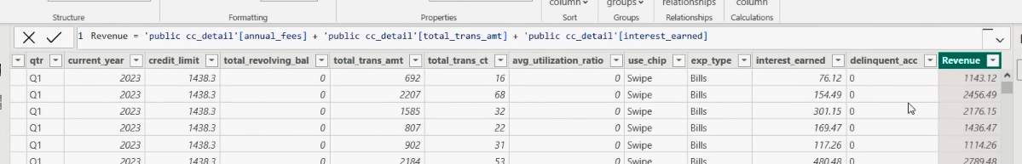

1. As we can see, the **week_num** can’t get sort properly, so we will make a new column for **week number**

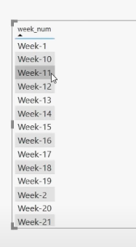

Go to **public.cc_detail** --> **New column**

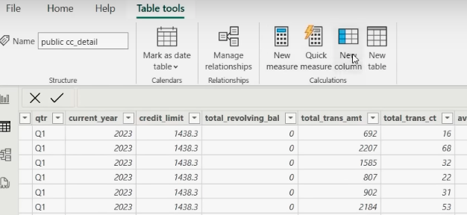

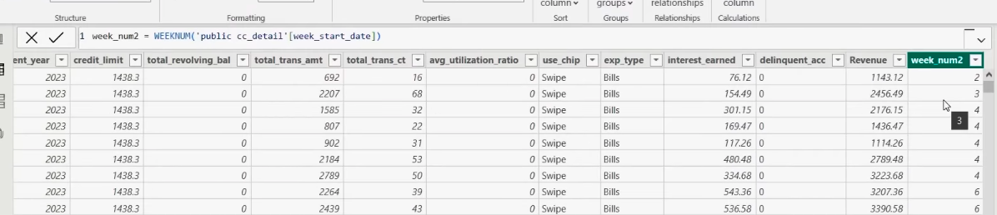

1. Now, we want to calculate the **Sum of Revenue** for **every single week**, so we can calculate the **difference** between the **weekly Revenues**

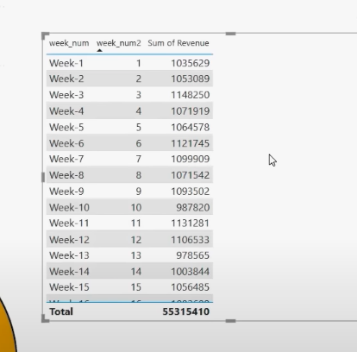

Go to **public.cc_detail** --> **New Measure**

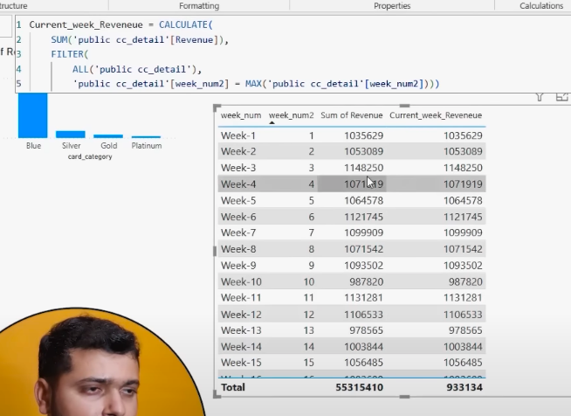

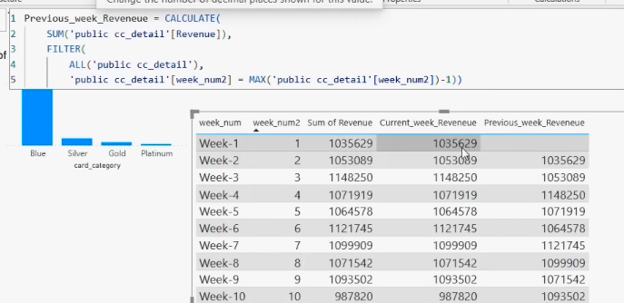

Now, to calculate the **Revenue change % for every 2 weeks**

**Revenue change % = (**Current or final value – previous value) / previous value

Go to **public.cc_detail** --> **New Measure**

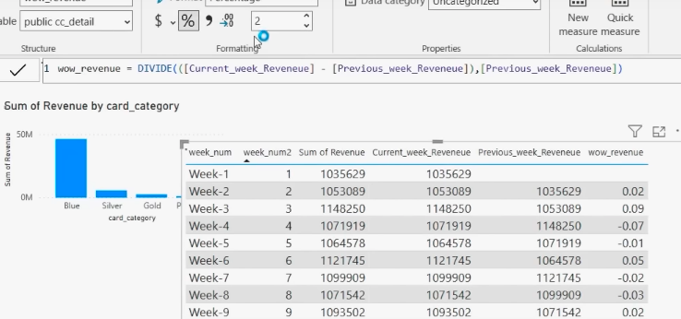

Click on the **wow_revenue** % sign, to get the wow_revenue in %.

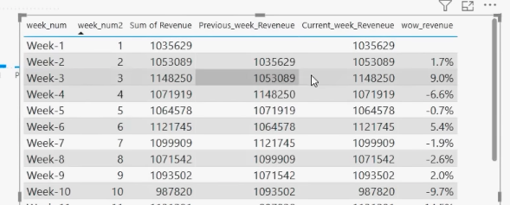

Final table:

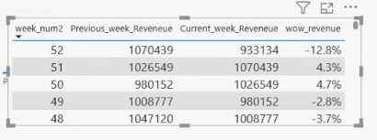

**XXXXXXXXXXXXXXXXXXXXXXXXX**



Open a new **worksheet** --> get a **TextBox** and name the Dashboard

Create a **Line & stacked column chart**

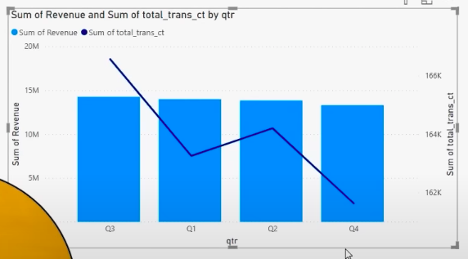

Now, sort the Q!, Q2,…

To sort: click 3 dots (…) on top, sort axis --> Qtr

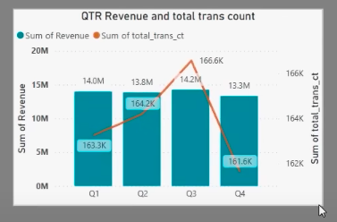

First, chart is ready

**To copy the Format of one chart into another:**

1. Click an already formatted chart

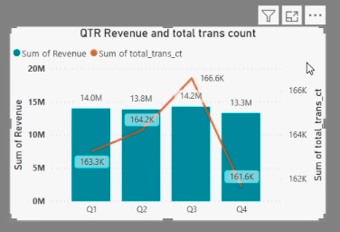

1. Click format painter option on top

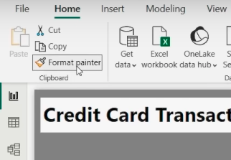

1. Then, click on the newly created chart to impose copied format

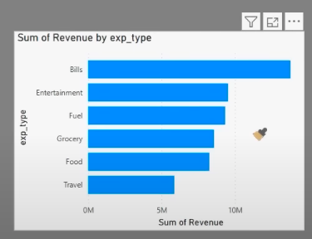

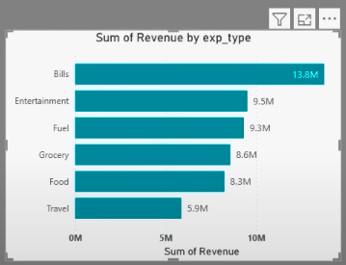

**Dashboard 1: Credit Card Transaction Report**



**Dashboard 2: Credit Card Customer Report**



Now, both the dashboard templates are finalised.

------------------>

**Adding new weekly data into the dataset**

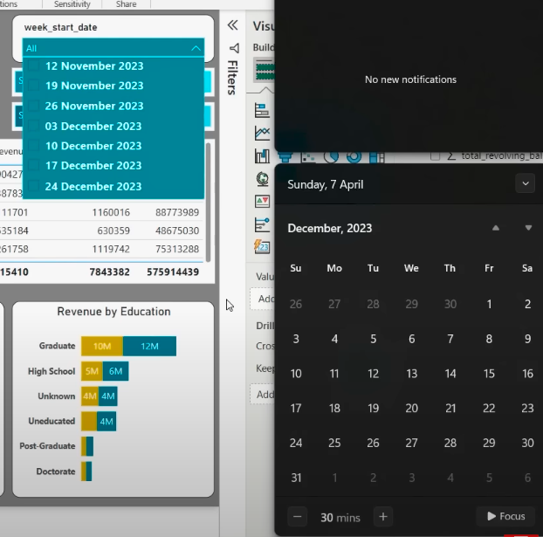

So, now we are adding data from **31 December** to ahead.

Now, go to SQL Postgres and add the data

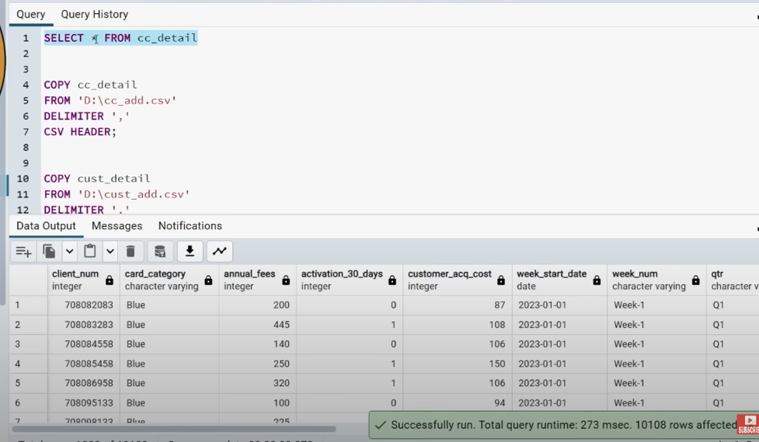

As we can see, still we have 10108 data rows



Now, go to Power BI and refresh the data.

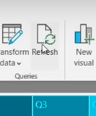

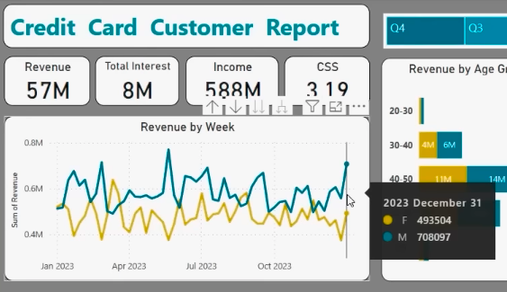

As you can see, the data is updated with one more week.

**Sharing Insights**

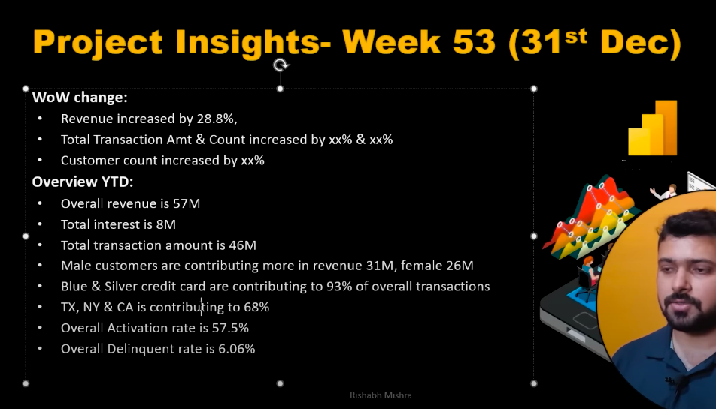

**XXXXXXXXXXXXXXXXXXXXXXXXX**



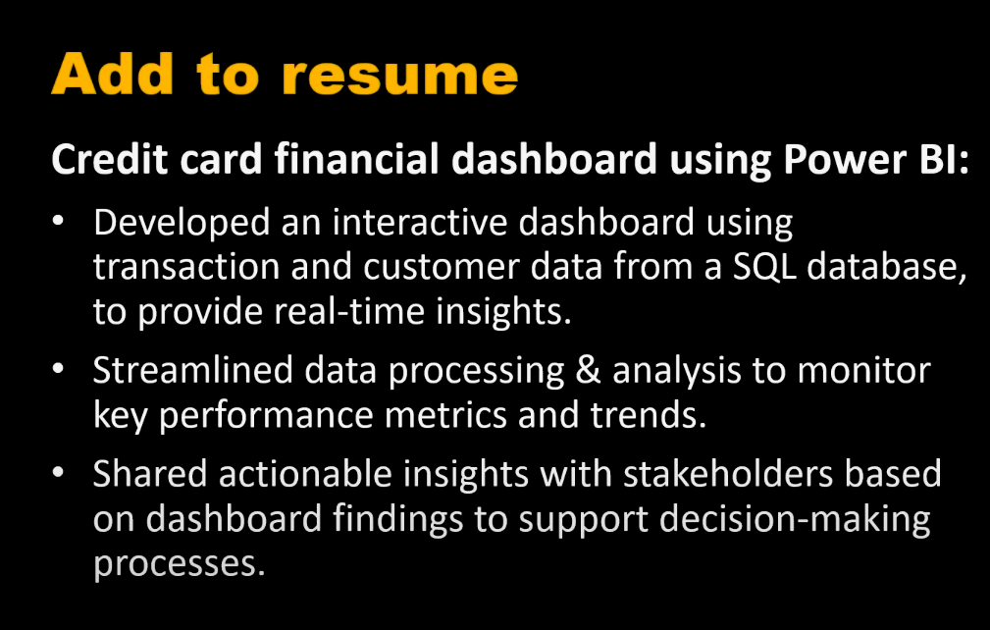

Go to **FILE** --> **Export** --> **Export to PDF**

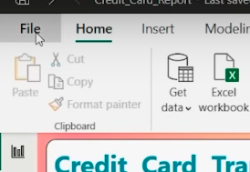

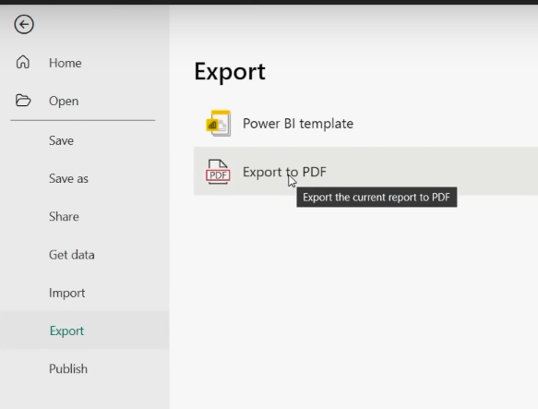

References:

* <https://www.youtube.com/watch?v=8XoDVwWdaqI&t=181s>
* <https://github.com/rishabhnmishra/Credit_Card_Financial_Dashboard>